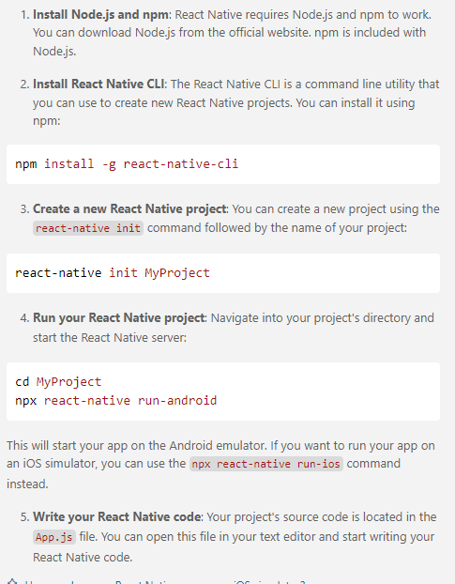

npx react-native run-android

Yes, there are several ways to manually install your app without using a USB cable. Here are the most common methods:

1. Wireless ADB (Android Debug Bridge):

* Enable Wireless Debugging on your device:
  + Go to Settings > About Phone (or About Tablet) > tap "Build number" 7 times to enable Developer Options.
  + Go back to Settings > Developer Options > enable "Wireless debugging."
  + Note down the IP address and port number displayed.
* Connect over Wi-Fi:
  + Ensure your device and computer are on the same Wi-Fi network.
  + Open a terminal window on your computer and use the adb connect <IP_address>:<port> command to connect wirelessly.
  + Once connected, use adb install <path_to_apk> to install your app's APK file.

[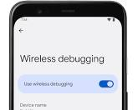](https://developer.android.com/tools/adb)

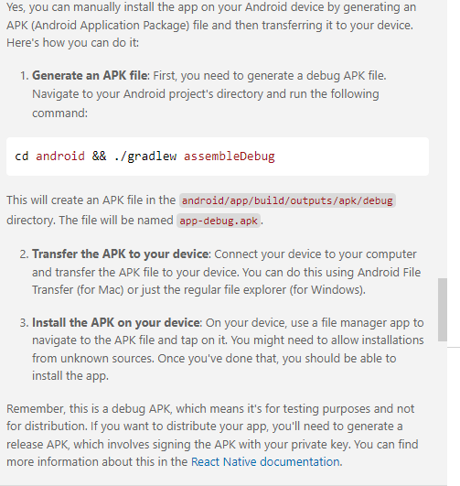

react-native run-android

cd android && ./gradlew assembleDebug

so show all the steps of creating a react native application